**Relevant Work**

* **Multi-Agent Actor-Critic for Mixed Cooperative-Competitive Environments (MADDPG)**
  + Link: <https://arxiv.org/pdf/1706.02275.pdf>
  + 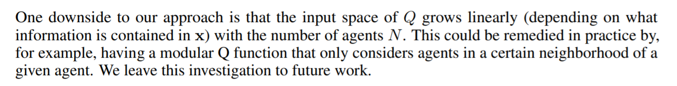
* **Scalable Reinforcement Learning of Localized Policies for Multi-Agent Networked Systems (Locality)**
  + Link: <https://arxiv.org/pdf/1912.02906.pdf>
  + 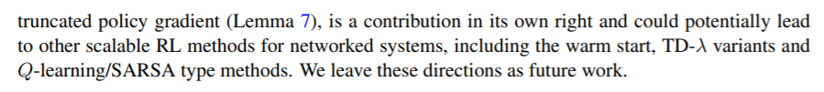
* **CM3: Cooperative Multi-goal Multi-stage Multi-agent Reinforcement Learning**
  + Link: <https://arxiv.org/pdf/1809.05188.pdf>
  + 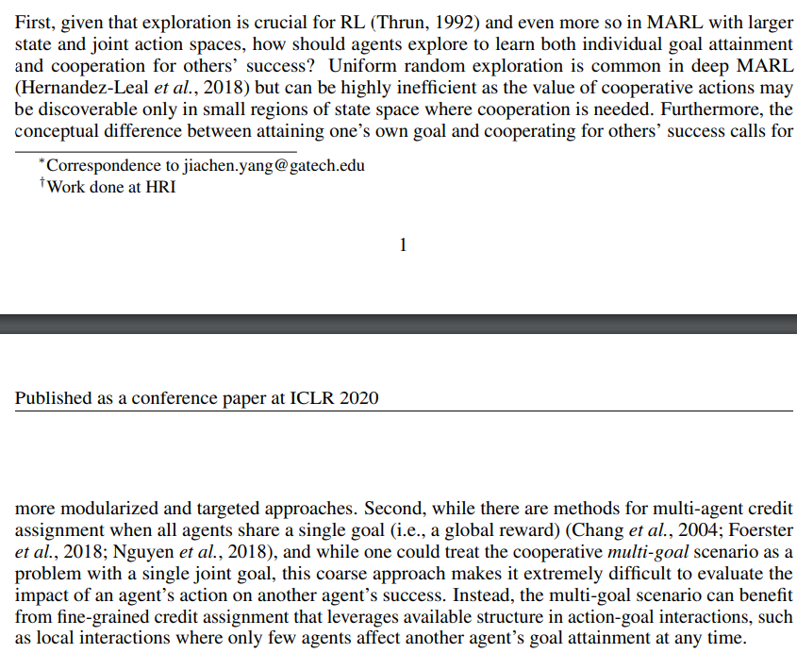
* **Graph Convolutional Reinforcement Learning**
  + Link: <https://arxiv.org/abs/1810.09202>
* **Value-Decomposition Networks For Cooperative Multi-Agent Learning (VDN)**
  + Link: <https://arxiv.org/pdf/1706.05296.pdf>
  + 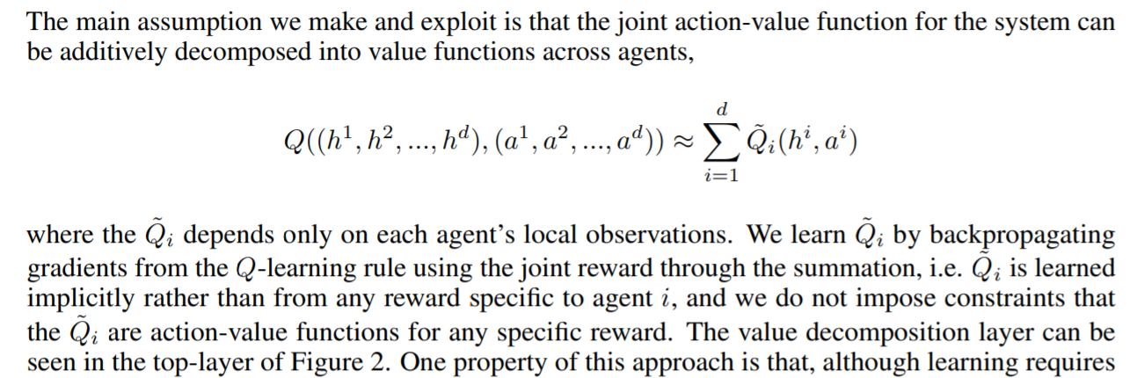
  + Learning implicity can be problematic – what rewards are relevant?
  + 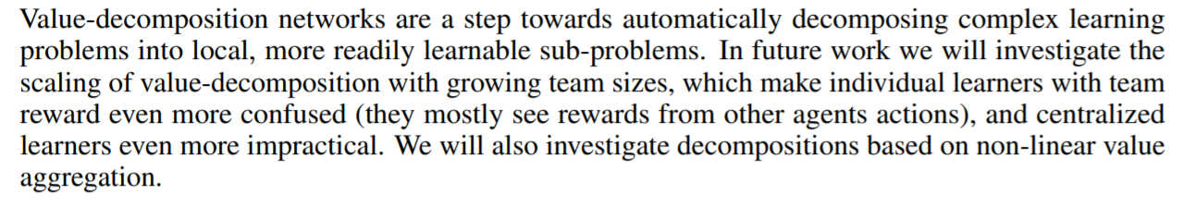
  + EXACTLY!